S.S.E.S. Amravati’s Science College Congress-Nagar, Nagpur
Department of Physical Education
ANNUAL REPORT- (2023-2024)
(DEGREE-COLLEGE)
I am very glad to submit the Annual Report of sport Activities conducted during the academic session 2023-2024. The unique record of success of the college is well known all over Vidarbha. The achievement of the students in the field of sports and their all round development reflected through the prizes are the hallmark of institutional glory. I take an opportunity to present the report of their spectacular achievements. The college students participated in the following Games in District, Division, State, National, University, and Inter-University Tournaments.
DEGREE COLLEGE:-
Participations: 17 Men & 16 Women Team participated in various games & Sports of R.T.M. Nagpur University.
Men :- Fencing Base-Ball, Soft-ball, Power-Lifting, Karate, Cricket,Foot-ball, Rugby, Athletics, Basket- Ball, Judo, Archery, Boxing, Wrestling, Taekwondo, Badminton. Kabddi
Women : - Hand- Ball, Taekwondo, Wushu, Sepak– Takraw, Base-Ball, Mini Golf, Badminton Volley Ball, Wood ball, Soft Ball ,Archery, Yogasan, Athletics, Gymnastic, Korf –ball Rugby.
Activities Conducted & Organized:-
1st SUB –JUNIOR & 3rd SENIOR STATE CESTOBALL CHAMPIONSHIP – 2023-2024
Shivaji Science college, Dhanwate National College and Cestoball Association, Nagpur, jointly organize 1st sub - junior & 3rd Senior State Cestoball Championship -2023-2024 The Tournament was inaugurated by Shri Hemant W. Kalmegh, Adv. Abhijit Wanjari and Principal Dr. M.P. Dhore The tournament took place from 26/11/2023 to 29/11/2023.
2) Annual Sport Day: - Annual Sport Day was Celebrated in Memory of Dr. Panjabrao Deshmukh, founder Persident of Shri Shivaji Education Society Amaravati. This year our students conducted the sport Activities under the Banner of Department of physical Education. They Successfully Conducted the Inter- Collegiate Cricket, Kabaddi, Badminton, Tournaments.
3) Medical Examination Test & Physical Efficiency Test: - In addition to the above games & sports activities, we conducted Medical Examination test & Physical Efficiency test of our degree Students in January 2024. The statistical reports were submitted to the R.T.M. Nagpur University.

SECLECTED PLAYERS IN ALL INDIA INTER UNIVERSITY
TAEKWONDO (Women):-Ku. Akanksha K. Kirpan B.Sc. –III (ECSM) she was selected from R.T.M. Nagpur University in South-West Zone Inter University Taekwondo Championship. This event was organized by Jagdishprasad Jhabarmal Tibrewala University, Rajasthan Dated on 06/11/2023 to 09/11/2023.
ARCHERY (Women) :- Ku. Arya K. Raut B.C.A.- I and Ku. Vaishnavi D. Dhabre B.Sc. II (PCsM) were selected from R.T.M. Nagpur University in South-West Zone Inter University Archery Championship. This event was organized by Guru Kashi University, Bhatinda dated on 19/12/2023 to 22/12/2023

FENCING(Men):- Mr. Aditya R. Selokar B.Sc.–III (CGM) Selected fom R.T.M. Nagpur University in South-West Zone Inter University Fencing Championship. This event was held from 23/12/2023 to 26/12/2023 Organized by M.G.M University, Arungabad and it was (Sambhaji Nagar)

HAND-BALL (Women):- Ku. Arya P. Dumbhare B.Sc.-III (CMBT) Selected from R.T.M .Nagpur University West Zone Hand Ball Championship Which was held at Udaipur Organized by Mohanlal Sukhadia University. This event was held from 19/01/2024 to 23/01/2024

RUGBY (Men) :- Mr. Jiwak D. Wasekar M.Sc.-I (Botany) was selected in All India Inter University Rugby Championship Which was held at Mohali Organized by CHANDIGHAR UNIVERSITY This event was held from 20/01/2024/ to 24/01/2024.

WUSHU (WOMEN) :- Ku. Sakshi S.Mohite M.Sc. II (Chem) & Ku. Manika D. Parihar B.Sc- I (SCsM) were selected in all India inter University Wushu Championship which was held at Jammu Organized by University of Jammu This event was held from 13/02/2024/ to 17/02/2024

BASE-BALL (Men) :- Mr. Anup S.Tiwari B.Sc.-III (CMBT) was a selected all India Inter University Base- Ball Competition held at Guwahati, and Organized by The Assam Royal Global University. This event was held from 22/02/2024/ to 26/02/2024.

KORF-BALL (Combin):-Ku. Vedanti D. Wakulkar B.Sc.-II (CMBT) was a Selected All India Inter University Korf ball Competition held at Chennai and Organized by B.S .Abdur Rahman Crescent institute of Science & Technology. This event was held from 01/03/2024/ to 05/03/2024

BASE-BALL(Women):- Ku. Nidhi V. Khambalkar B.Sc. III (PCsM) was selected in all India Inter University Base Ball Competition Which was held at Baramati, and Organized by Savitribai Phule Pune University. This event was held from 24/03/2024/ to 28/03/2024.

NATIONAL LEVEL:- Ku. Vaishnavi D. Dhabre B. Sc. II (PCsM) She was a Selected all India Inter University Archery women national level Championships held at Patiala and organized by PANJAB UNIVERSITY. This event was held from 28/12/2023 to 31/12/2023.

Express my heartfelt gratitude to our esteemed Principal for his constant support and encouragement and motivating us to do better every year.
I also extend my gratitude to the management of Shri. Shivaji Education Society Amravati’s for always co-operating and supporting our department.

Head of Deptt.
(Physical Education)

ALL INDIA INTER UNIVERSITY (COLOUR HOLDER)
2023-2024

Sr. No | Name of Players | Class | Game | Venue | Dated
1 | Akanksha K. Kirpan | B.Sc. III (ECsM) | Taekwondo | Rajasthan | 06/11/23 to 09/11/23
2 | Arya K. Raut | B.C.A.- I | Archery | Bhatinda | 19/12/23 to 22/12/23
3 | Vaishnavi D. Dhabre | B.Sc.II (PCsM) | Archery | Bhatinda | 19/12/23 to 22/12/23
4 | Aditya R. Selokar | B.Sc.-III (CGM) | Fencing | Aurangabad | 23/12/23 to 26/12/23
5 | Aryaa P. Dumbhare | B.Sc.-III (CMBT) | Hand-Ball | Udaipur | 19/01/24 to 23/01/24
6 | Jiwak D.Wasekar | M.Sc.-I (Botany) | Rugby | Mohali | 20/01/24 to 24/01/24
7 | Sakshi S. Mohite | M.Sc. II (Chem) | Wushu | Jammu | 13/02/24 to 17/02/24
8 | Manika D. Parihar | B.Sc.-I (SCsM) | Wushu | Jammu | 13/02/24 to 17/02/24
9 | Anup S. Tiwari | B.Sc.- III (CMBT) | Base-Ball | Guwahati | 22/02/24 to 26/02/24
10 | Vedanti D. Wakulkar | B.Sc.-II (CMBT) | Korf-Ball | Chenni | 01/03/24 to 05/03/24
11 | Nidhi V. Khambalkar | B.Sc.-III (PCsM) | Base-Ball | Baramati | 24/03/24 to 28/03/24
12 | Harshita M. Sutar | B.C.A -I | MiniGolf

NATIONAL LEVEL PLAYER
Sr. No | Name of Players | Class | Game | Venue | Dated
01 | Ku.Vaishnavi D. Dhabre | B.Sc.-II (PCsM) | ARCHERY | PATIALA | 28/12/23 to 31/12/23

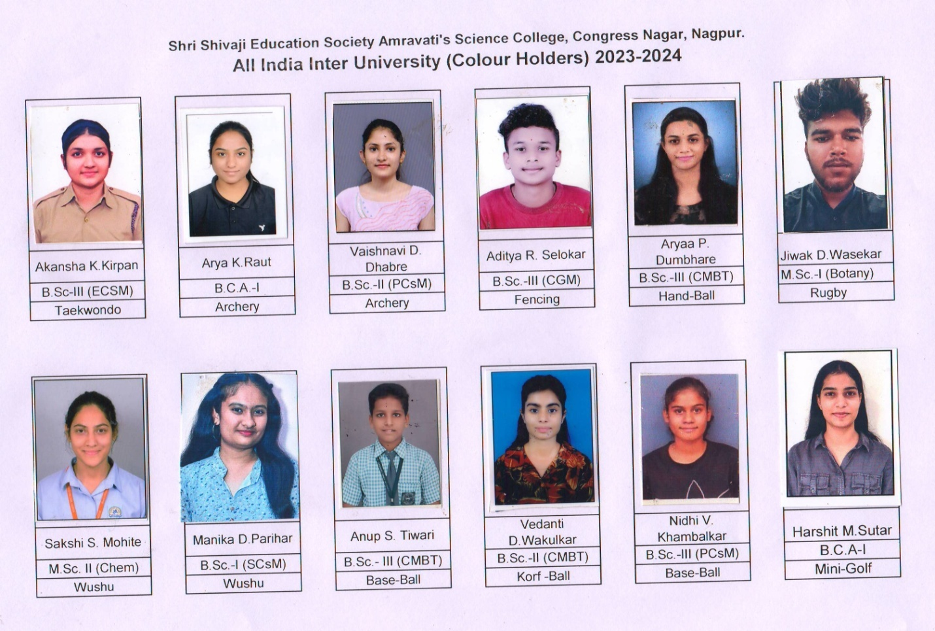

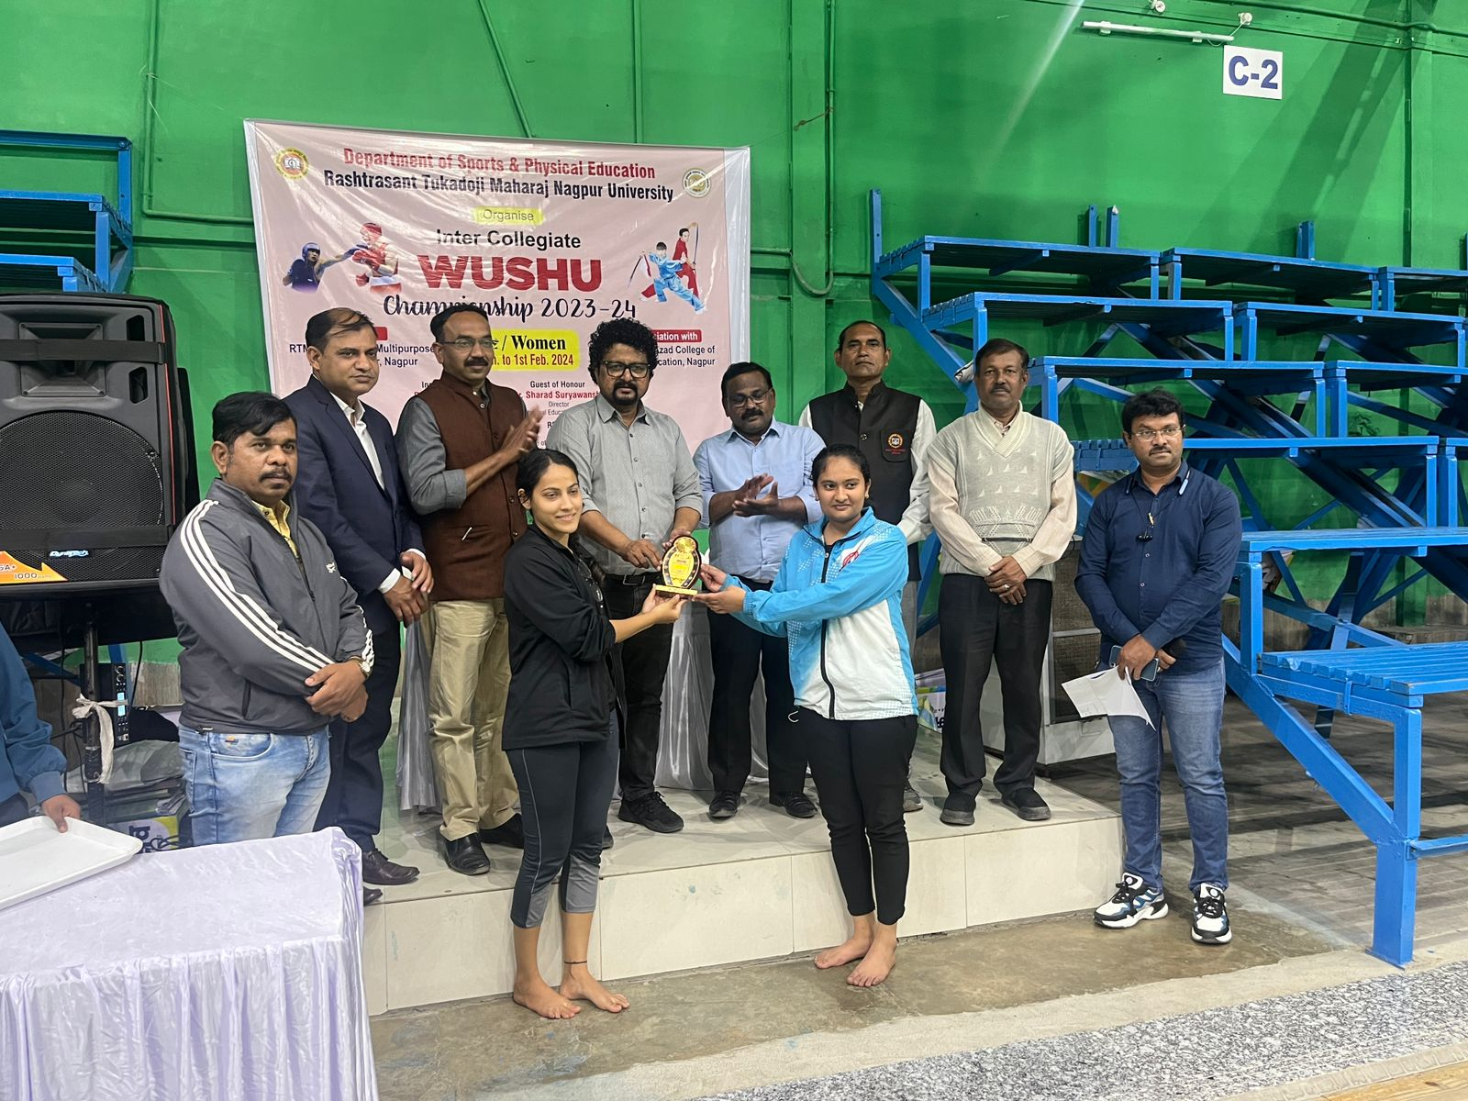
WUSHU (WOMEN) :- Ku. Sakshi S.Mohite M.Sc. II (Chem) & Ku. Manika D. Parihar B.Sc- I (SCsM) were selected in all India inter University Wushu Championship which was held at Jammu Organized by University of Jammu This event was held from 13/02/2024/ to 17/02/2024
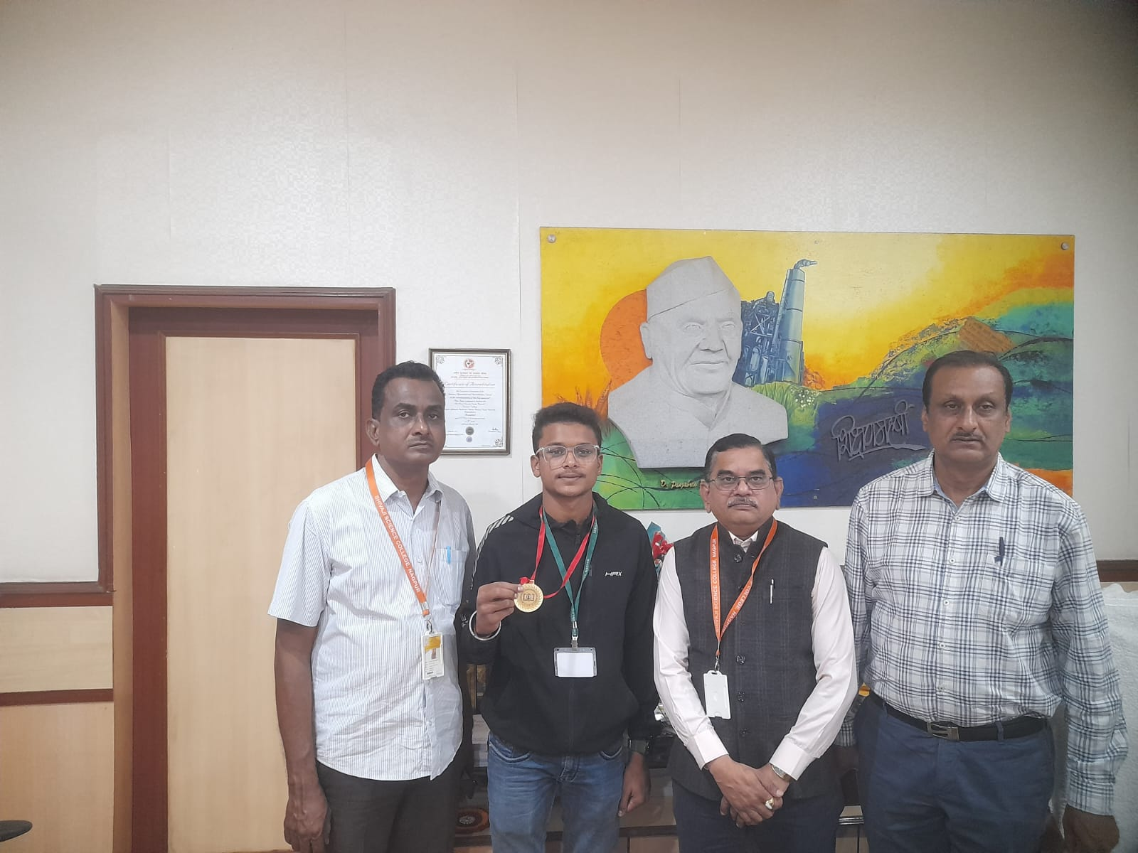
FENCING(Men):- Mr. Aditya R. Selokar B.Sc.–III (CGM) Selected fom R.T.M. Nagpur University in South-West Zone Inter University Fencing Championship. This event was held from 23/12/2023 to 26/12/2023 Organized by M.G.M University, Arungabad and it was (Sambhaji Nagar)

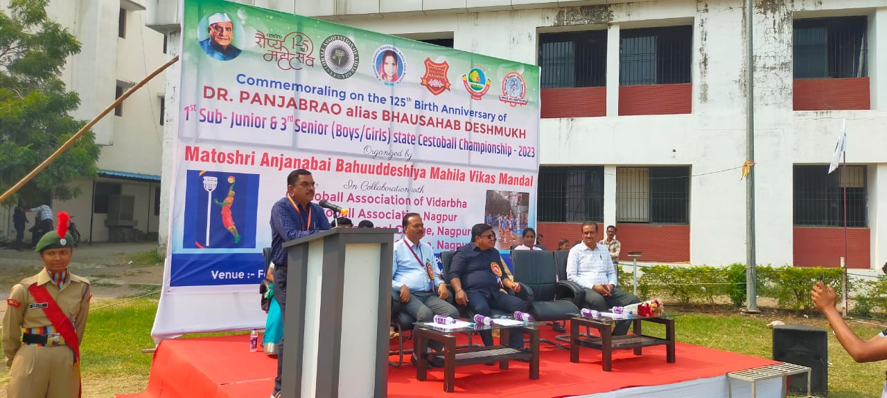
1st SUB –JUNIOR & 3rd SENIOR STATE CESTOBALL CHAMPIONSHIP – 2023-2024 Shivaji Science college, Dhanwate National College and Cestoball Association, Nagpur, jointly organize 1st sub - junior & 3rd Senior State Cestoball Championship -2023-2024 The Tournament was inaugurated by Shri Hemant W. Kalmegh, Adv. Abhijit Wanjari and Principal Dr. M.P. Dhore DNC Principal O.S Deshmukh The tournament took place from 26/11/2023 to 29/11/2023.
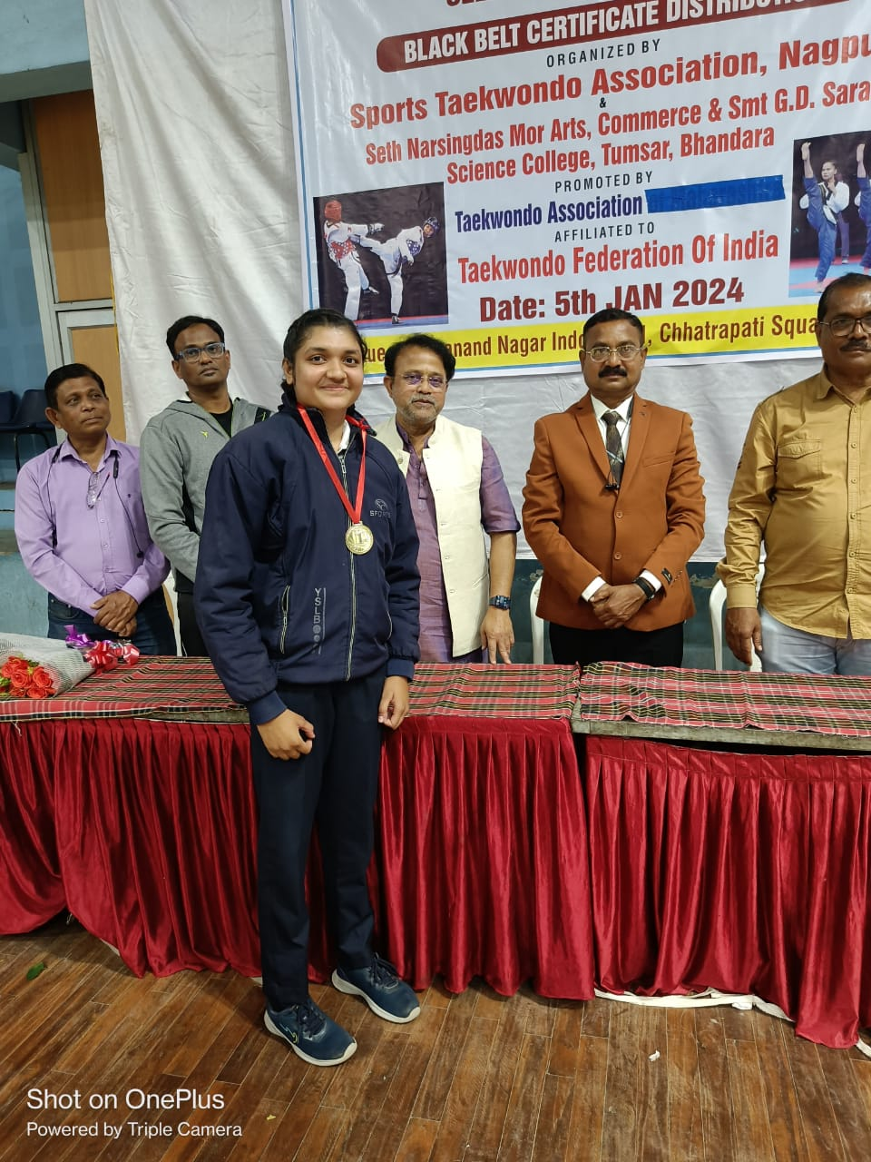
TAEKWONDO (Women):-Ku. Akanksha K. Kirpan B.Sc. –III (ECSM) she was Gold Medal selected from Taekwondo Federation of India Senior Championship. This event was organized by Sport Taekwondo Association, Nagpur. Dated on 05/01/2024. and she was selected from R.T.M. Nagpur University in South-West Zone Inter University Taekwondo Championship. This event was organized by Jagdishprasad Jhabarmal Tibrewala University, Rajasthan Dated on 06/11/2023 to 09/11/2023.
Head of Deptt.
(Physical Education)

